Harmony Pond £5495
Our entry-level still water pond
Pond footprint up to 2.2m x 1.9m
Mowing separation zone up to 15 cm
Average depth 45 cm (can include small deeper area for fish cave). Vertical elevations.
British made highest quality EDPM liner (4m x 2.9m)
Commercial grade underlay & overlay
Hand chosen rocks – slate or yorkstone
Fully rocked – no exposed liner (reduced by £500 if only the upper shelf is rocked)
Rounded pebbles & gravel surfaces
Planting pockets
10 aquatic plants – British natives where available
Additional options; Lighting £350, air pump £150
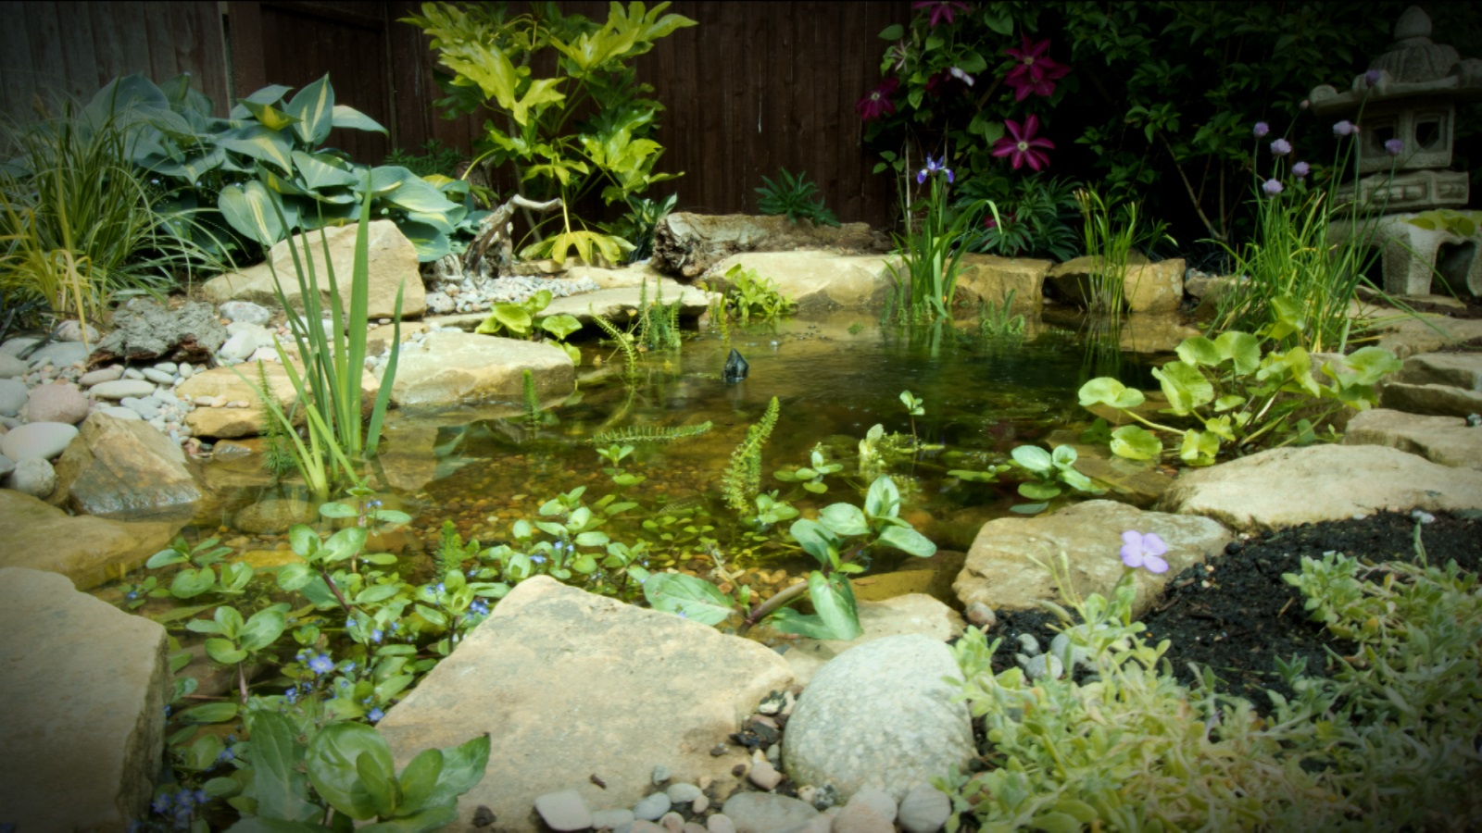

Sanctuary Pond £8995
Our entry-level moving water pond
Ecosystem filtration to include biofalls biological filter & intake bay mechanical filtration
Waterfall 1m length x 30 cm height.
High quality variable flow pump (in wildlife friendly separation vault)
High quality plumbing and piping (no cheap corrugated piping)
Pond footprint 2.6m x 2.0m
Mowing separation zone up to 15 cm
Average depth 45 cm (can include small deeper area for fish cave). Vertical elevations.
British made highest quality EDPM liner (4.5m x 3.3m)
Commercial grade underlay & overlay
Hand chosen rocks – slate or yorkstone
Fully rocked – no exposed liner (reduced by £500 if only the upper shelf is rocked)
Rounded pebbles & gravel surfaces
Planting pockets
10 aquatic plants – British natives where available
Additional options; Lighting £350, air pump £150, longer / higher waterfall POA, spillway bowl £900
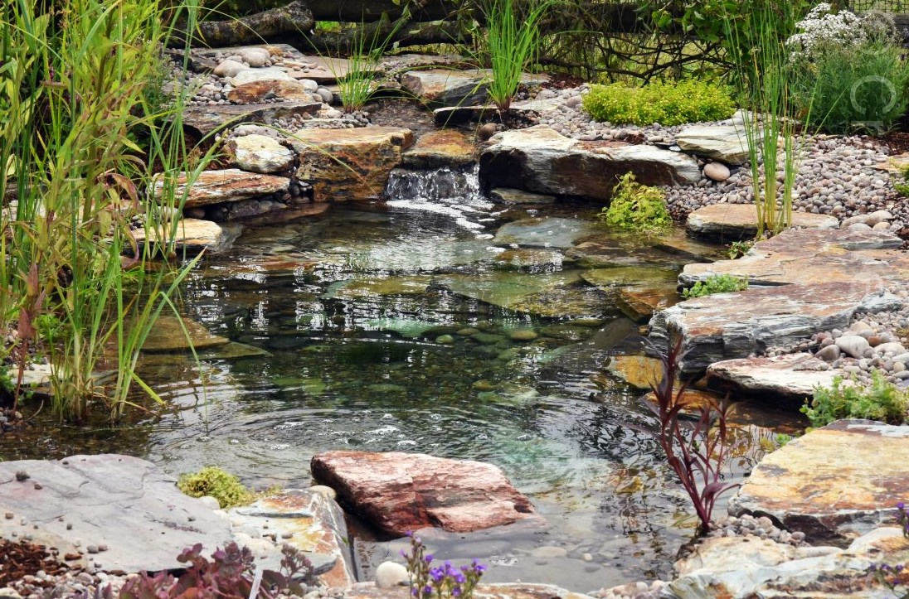

Halcyon Pond £9995
Our medium sized moving water pond
Ecosystem filtration to include biofalls biological filter & intake bay mechanical filtration
Waterfall 1.4m length x 30 cm height
High quality variable flow pump (in wildlife friendly separation vault)
High quality plumbing and piping (no cheap corrugated piping)
Pond footprint 3.3m x 2.3m
Mowing separation zone up to 15 cm
Average depth 45 cm (can include small deeper area for fish cave). Vertical elevations.
British made highest quality EDPM liner (4.5m x 3.3m)
Commercial grade underlay & overlay
Hand chosen rocks – slate or yorkstone
Fully rocked – no exposed liner (reduced by £700 if only the upper shelf is rocked)
Rounded pebbles & gravel surfaces
Planting pockets
15 aquatic plants – British natives where available
Additional options; Lighting £350, air pump £150, longer/higher waterfall POA, large rocks POA, bowl £900
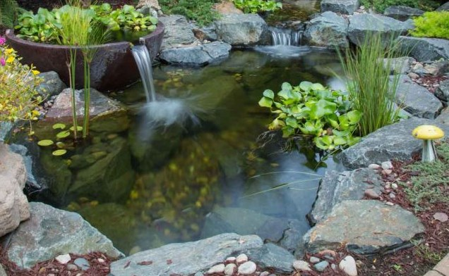
Above pond including option of large rocks & spillway bowl

